National University of Computer and Emerging Sciences, Lahore Campus

 | Course Name: | Programming Fundamentals | Course Code: | CS-1002
 | Degree Program: | BS(CS-SE-DS) | Semester: | Fall 2021
 | Exam Duration: | 180 Minutes | Total Marks: | 60
 | Paper Date: | 14-Jan-2022 | Weight
 | Section: | ALL | Page(s): | 12
 | Exam Type: | Final Exam
Student : Name:_____________________________ Roll No.________________ Section:_______
Instruction/Notes: | Do not use any built-in functions.  You must use rough sheets for planning your answers.  Once finalized, write your answers in the provided space.  Do not attach rough sheets with this paper. Good luck!

Question 1: [Find Output] [3 x 3 Points]
Determine the output produced by each of the following program segments
Program | Output
void Student_info(char data[]) {  int session = (data[0] - '0');  session = (data[1] - '0') + (session * 10);  cout << "Session: 20" << data[0] << data[1]  << " - 20" << session + 4 << endl;  if (data[2] == 'L')  cout << "Your campus is: Lahore" << endl;  if (data[2] == 'K')  cout << "Your campus is: Karachi" << endl;  if (data[2] == 'I')  cout << "Your campus is: Islamabad" << endl;  cout << "Your ID is: " << data[4] << data[5]  << data[6] << data[7] << endl;  }  int main(){  char student1[10] = "20L-1055";  char student2[20] = "21K-1234";  Student_info(student1);  return 0;  } | Session: 2020 - 2024  Your campus is: Lahore  Your ID is: 1055
int main(){  int A[5] = {1, 2, 3};  for(int I = 0; I < 5 ; I++)  if (A[I] % 2)  cout<< “ODD NUMBER"<<endl;  else  cout<< “EVEN NUMBER"<<endl;  return 0;  } | ODD NUMBER  EVEN NUMBER  ODD NUMBER  EVEN NUMBER  EVEN NUMBER
int main()  {  int num = 10;  int temp, count;  for(; num > 0 ; num-- )  {  temp= num;  count = 1;  while(temp>0)  {  temp= temp-count;  count++;  }  if (temp ==0)  cout<<num<<"is good"<<endl;  }  return 0;  } | 10is good  6is good  3is good  1is good

Question 2: [Writing Tiny Functions] [4 x 4 Points]
Given descriptions of the functions write C++ code for each of the functions. You are not allowed to use loops in your function definitions

isSpecialChar takes a character as parameter and returns true if this character is a special character and false otherwise. Characters excluding alphabets and numbers are special characters.

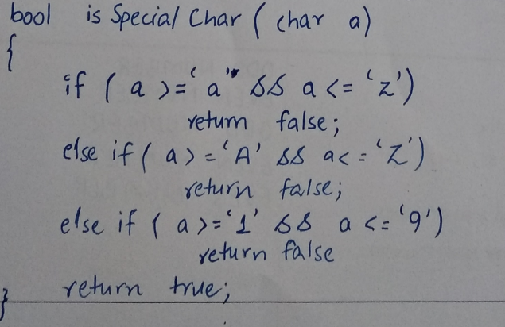

toUpperCase takes a character as a parameter and converts this character into an upper case alphabet if it is in lower case. This function should not return any value.
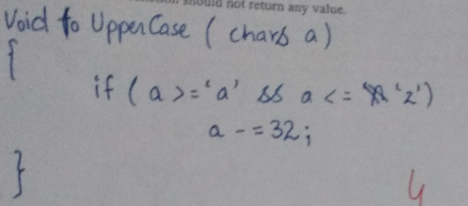

calculateRetailPrice takes two read only parameters, the price of an item and general sales tax (GST) in percentage. It calculates and returns the total price of the item where Total price is price + GST. As an example, if the price is 200 and GST is 16%, then the total price is 232.
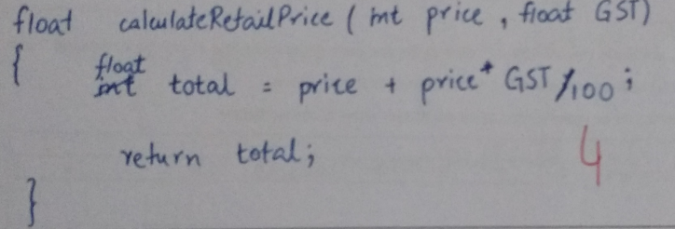

MinMax, has two integer reference parameters. The function must be written such that the function stores the smaller value in the first parameter and larger value in the second parameter.
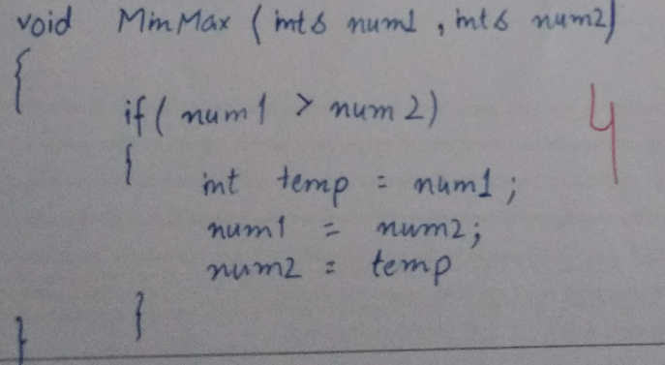

Question 3: [Pascal’s Triangle] [8 + 5 Points]

A triangular arrangement of coefficients in the binomial expansion of the form (x + y)^{n} with n = 0, 1, … is called Pascal’s triangle. The first seven rows of this triangle are shown below
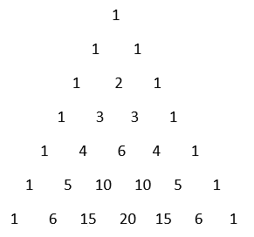 | 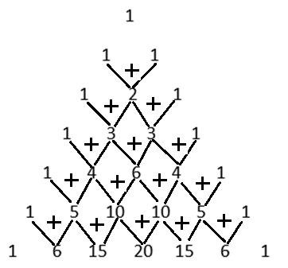

There are n + 1 numbers in the nth row of this triangle and each succeeding row of can be computed from the previous row by adding corresponding two numbers as shown above.
A row of this triangle can be represented using an integer array as shown below
Row 0 of Pascal’s triangle | 1 0 0 0 0 0 0 … 0
Row 3 of Pascal’s triangle | 1 3 3 1 0 0 0 … 0

Part a) In the space provided on the next page, write a C++ function that has an integer array called Pascal_Tiangle_Row as one of its parameter along with an integer parameter n. The value of the integer will specify the row number of the Pascal’s triangle already stored in the array with first row number starting at 0. The function must use this array to generate and return the next row of the triangle to the calling function.
For example if an array {1, 0, 0 ,0, .., 0} is passed to the function with n = 0 then the function must return
{1, 1, 0, 0, …, 0} using the same array and if the function gets the array {1, 3, 3, 1, 0, …, 0} as the argument with n = 3 then it must return {1, 4, 6, 4, 1, 0, …, 0} using the same array.

ANSWER Part a

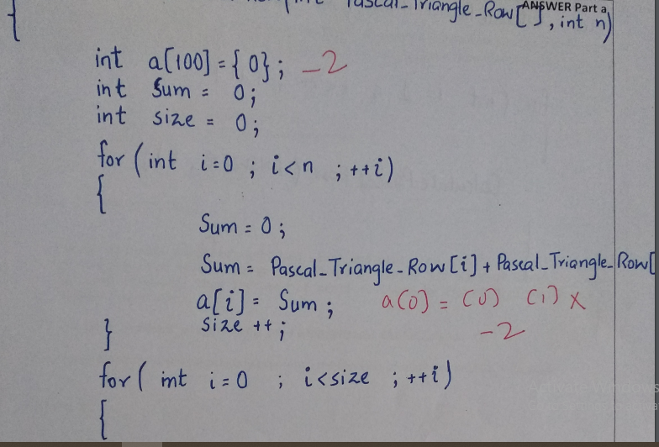
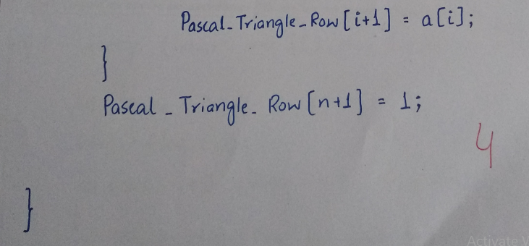

Part b) Write another C++ function that uses the function of part a) to compute and return the nth row of Pascal’s triangle to the user. This function will have two parameters i) an integer array ANSWER initialized all to 0 and an integer n specifying the required row of the triangle. For example, if the function is passed an array {0, 0, 0, 0, 0, 0, 0, 0, 0} and n = 6 the function must set the array values to {1, 6, 15, 20, 15, 6, 1, 0, 0}.
ANSWER Part b

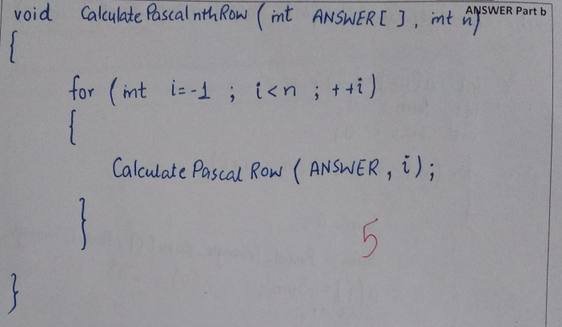

Question 4: [Merge Sentences] [10 Points]

Without modifying the main function given below, implement the necessary code/functions so that the main function works properly without any syntax or logical errors as per the given requirements. Don’t use any built-in functions.

int main()
{
char sent1[50] = " I am student of Bachelors of CS";
char sent2[50] = " I love programming fundamentals ";
char combined[100];

merge(sent1, sent2, combined);

cout << combined<<endl;

/*
The merge function combines sent1 and sent2 and place the answer into a third char array combine. You have to merge the arrays by taking 1st word of sent1 followed by 1st word of sent2, then 2nd word of sent1 followed by 2nd word of sent2 and so on. Combine contains:
I I am love student programming of fundamentals Bachelors of CS

Your merge function must work properly even when the contents of sent1 and sent2 are changed.

*/
return 0;
}

Your solution should not contain any nested loops. You may use any number of sequential loops.

ANSWER

BLANK PAGE FOR ANSWER
void merge(char s1[], char s2[], char comb[])
{
//Assumptions: 1. Every word is separated by exactly 1 space.
// 2. Non-alphabets are treated like alphabets.
// 3. No leading or trailing spaces.

int i = 0, j = 0, k = 0;
int turn = 1;

while (s1[i] != '\0' && s2[i] != '\0')
{
if(turn == 1)
{
if(s1[i] == ' ')
turn = 2;

comb[k] = s1[i];
k++;
i++;

}
else
{
if(s2[j] == ' ')
turn = 1;

comb[k] = s2[j];
k++;
j++;
}

}
comb[k] = ' ';
k++;
while (s1[i] != '\0' )
{
comb[k] = s1[i];
k++;
i++;
}

while (s2[i] != '\0')
{
comb[k] = s2[j];
k++;
j++;
}

}

Question 6: [2D Array and Functions] [1 + 3 + 8 Points]
For each of the following problems assume that two global variables have been declared as follows
int MaxRows = 10;
int MaxCols = 10;

Part a) In the space provided below declare a two dimensional array of integers having size 10 x 10
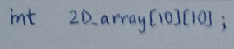

Part b) Write a function named init_Array that has three parameters i) a 2-D array called a 2D_Array having columns equal to 10, ii) an integer parameter R specifying the number of Rows to be initialized and iii) an integer argument value. The function must fill the top R rows of the 2D array by the value passed to it.

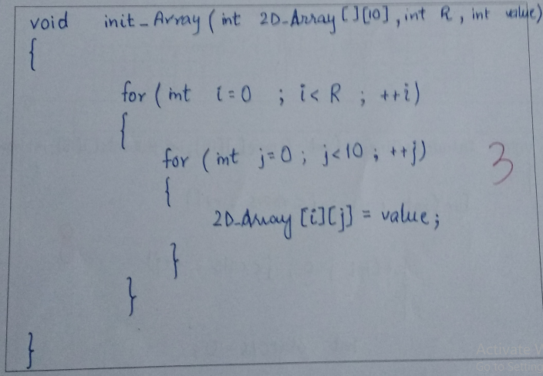

Part c) Each cell or slot of a 2D array Game contains either a 1 or a 0 with 1 representing the presence of some object at that position. Given a 2D array, we need to compute the number of objects in the neighborhood of each cell of the array. The neighborhood of a cell includes the cell itself and the cells surrounding it. For example, in a 10 x 10 array the cell at position [0][0] has only 4 cells in its neighborhood (including itself), whereas a cell at position [2][2] has 9 cells.

Write a C++ function that computes and store the count of neighbors for each cell of a 2D array called Game passed to it as one of the parameters. This function must store the counts of neighbors in a second array called N_Counts that is also passed to it as a parameter. Further, you must also assume that the maximum size of each array is 10 x 10 whereas the number of rows and columns to be used in calculations are also passed to the function as parameters.

Consider two sample examples consisting of arrays of sizes 5 x 4 and 3 x 5.
Example 1 | Example 2
Game  0 0 0 1  0 0 0 1  0 1 1 0  0 1 1 0  0 0 0 0 | Game  1 1 1 1 0  0 0 0 0 0  0 1 1 1 0

After calculating the count of neighbors for each position, the n_Counts array must contain the required information
N_Counts  0 0 2 2  1 2 4 3  2 4 5 3  2 4 4 2  1 2 2 1 | N_Counts  2 3 3 2 1  2 5 6 4 2  1 2 3 2 1

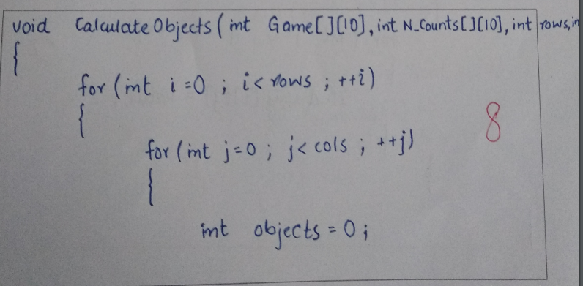
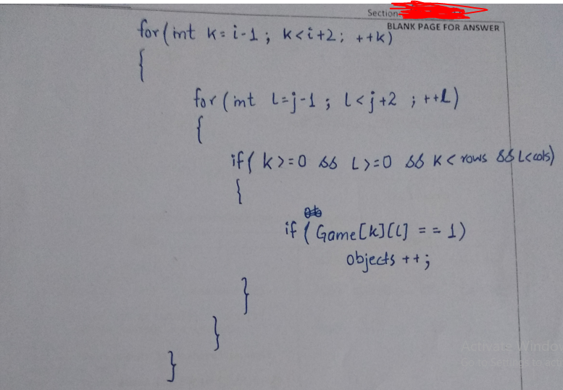
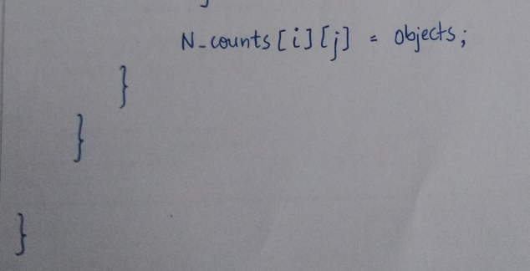

BLANK PAGE FOR ANSWER

BLANK PAGE FOR ANSWER

